# Lab 1

## Load the “farequote” data

1. From Machine Learning tab, select Data visualiser -> Import Data and load the “farequote.json” file

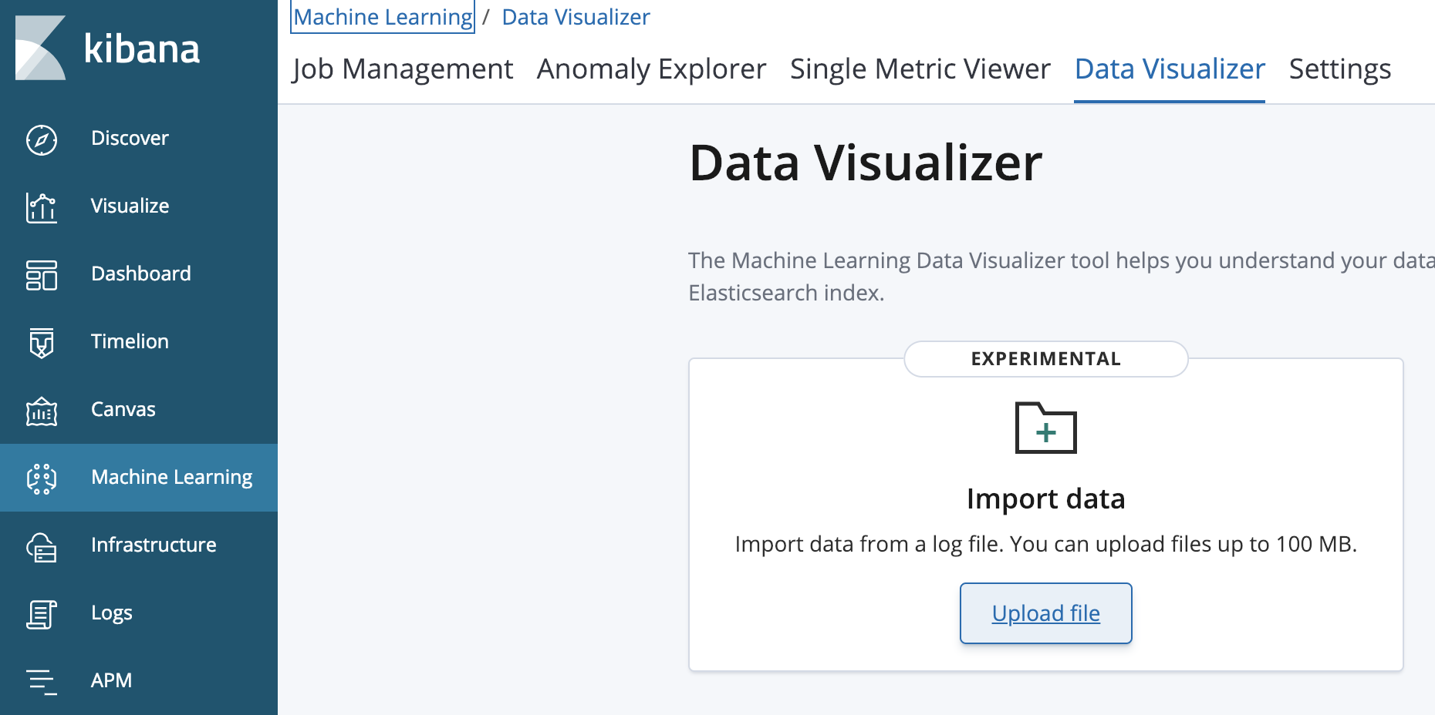

2. Cllick Import

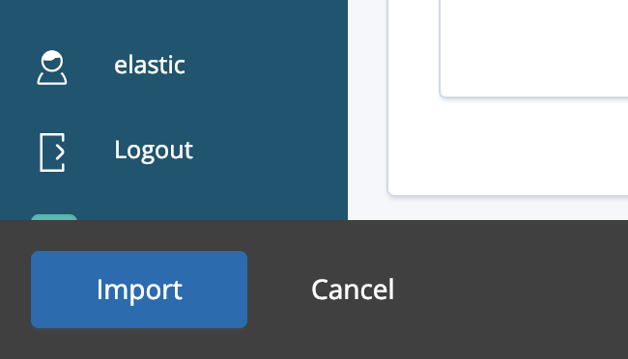

3. Enter the index name “farequote”

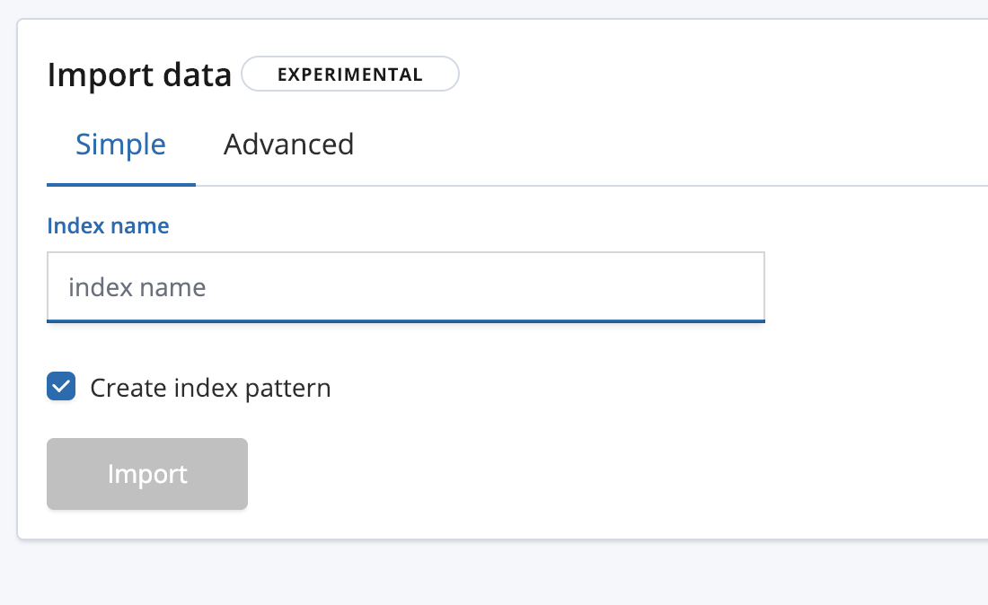

4. Wait for the Upload to finish.

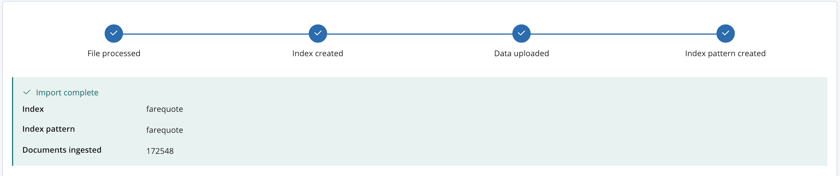

## Create and run machine learning job

1. In Machine learning, Job management, create a new job

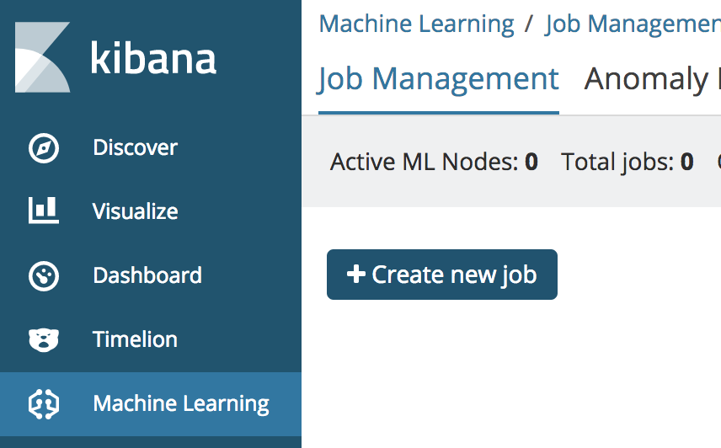

2. Chose farequote index pattern

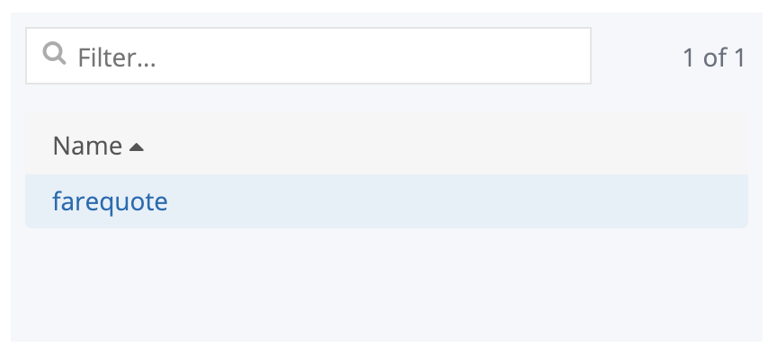

3. pick the Single Metric Wizard

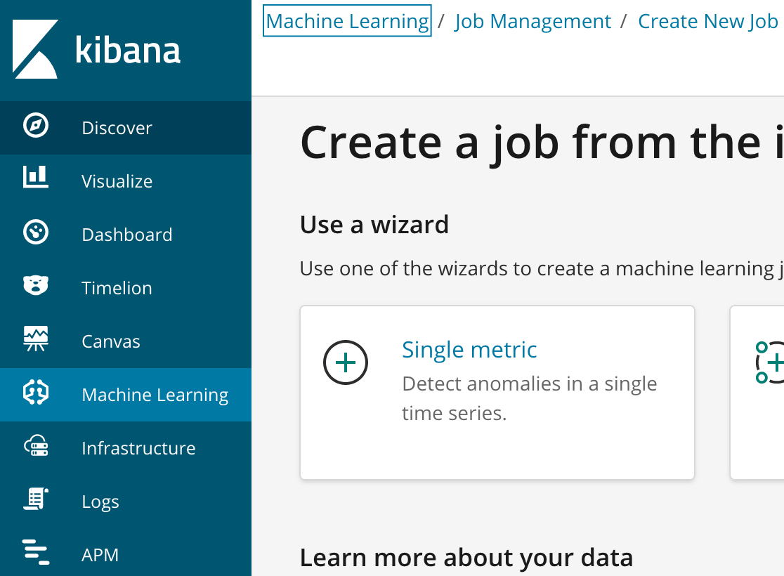

4. Configure the job

* Aggregation: count
* Field: <leave blank>
* Bucket span: 10m
* Click the “use full farequote data” Button
* Name: “farequote”
* click “Create Job”

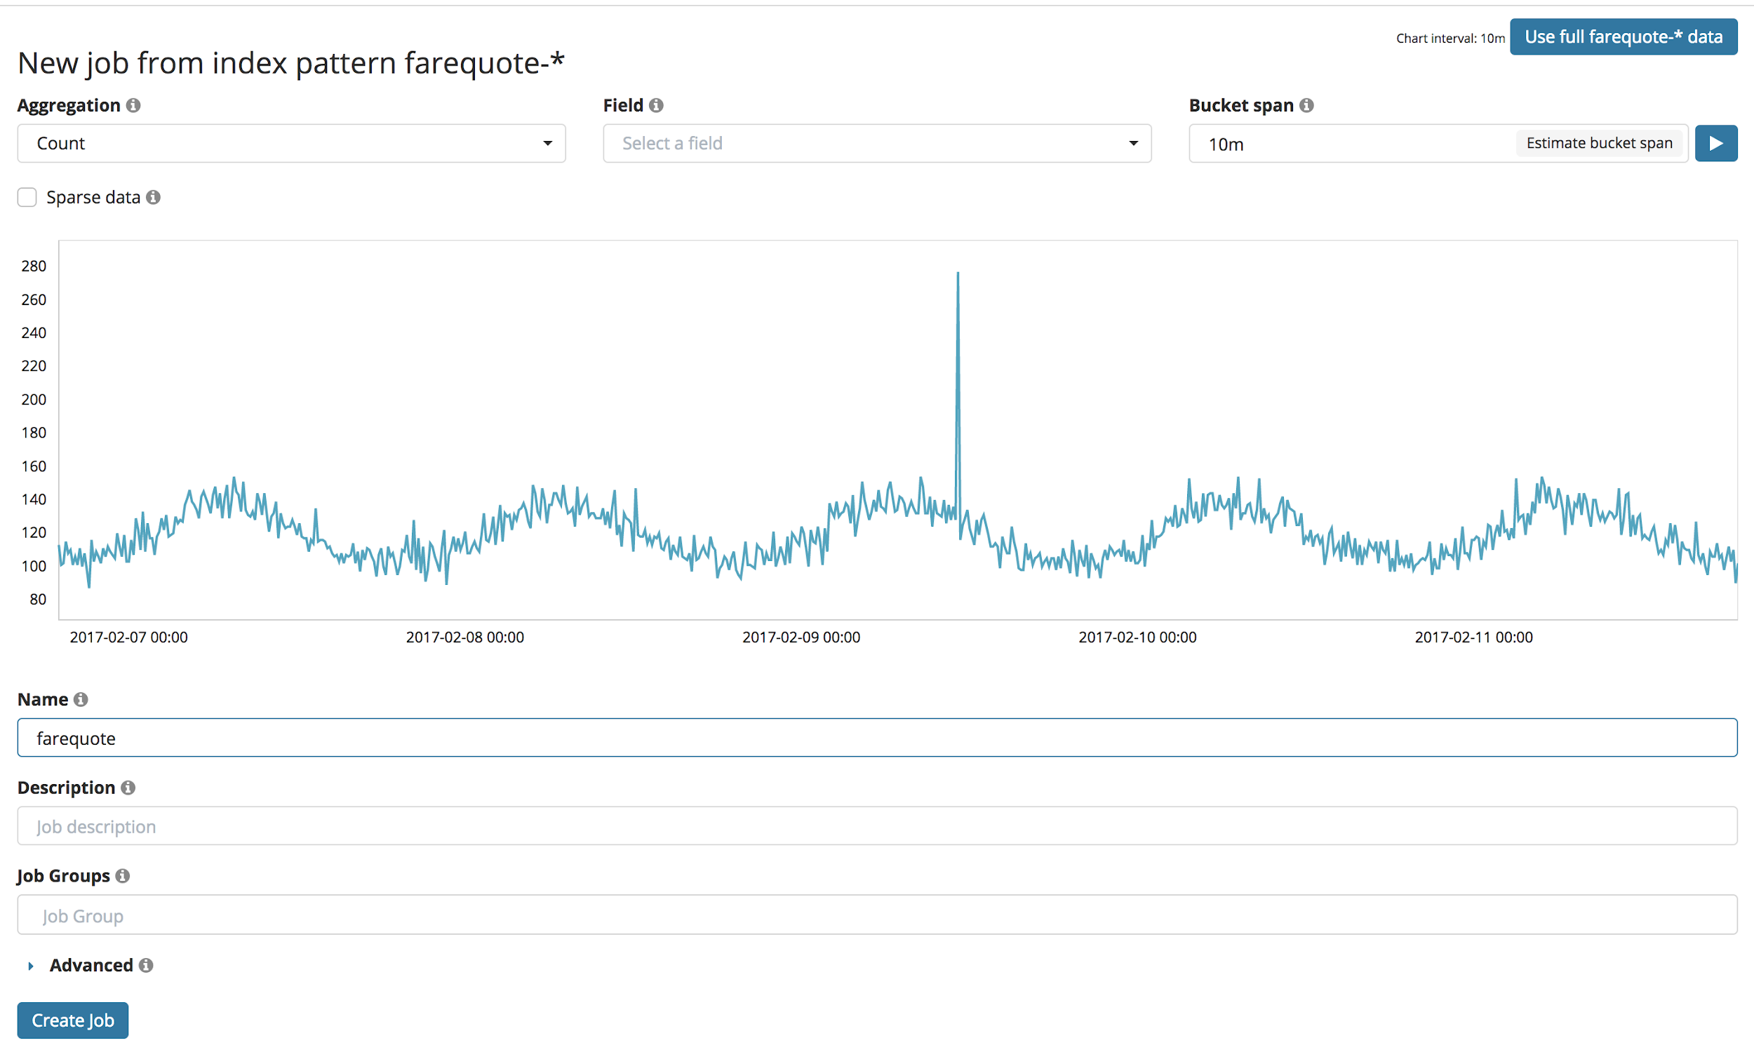

## See animated learning and view results

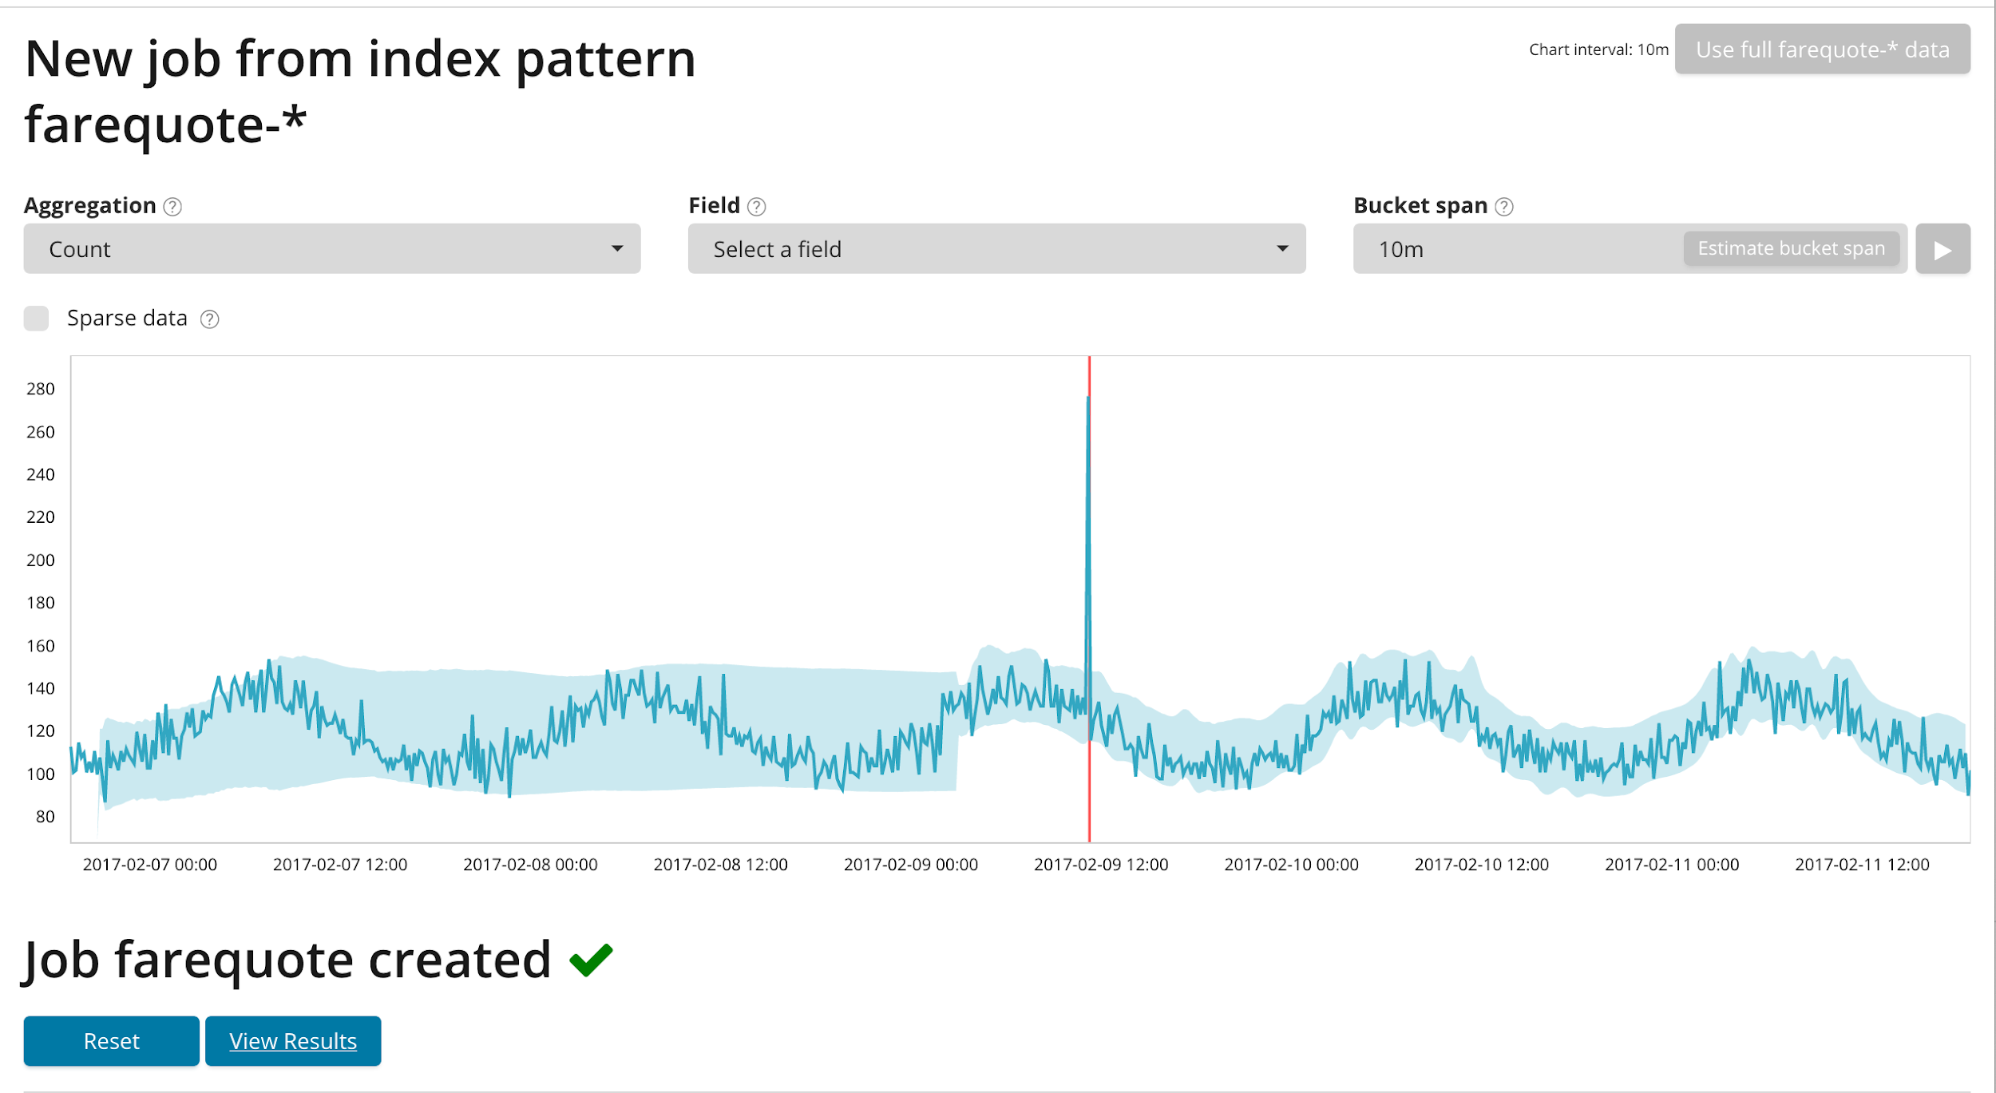

## Zoom in on anomaly

